**User Manual**

**for**

**ZetaFish**

Version 1.5

December 12, 2010

Prepared by:

Patrick Michalina Chad Albrecht  
Malick Noor



**Team Zeta Dragons**

CSC 478B - Software Engineering Capstone

Fall 2010

University of Illinois at Springfield



Revision History

|  |  |  |  |
| --- | --- | --- | --- |
| **Name** | **Date** | **Reason For Changes** | **Version** |
| Malick Noor | 12/4/2010 | Created First Draft | 1.0 |
| Malick Noor | 12/7/2010 | Added Section 6 | 1.1 |
| Patrick Michalina | 12/7/2010 | Added Sections 3 & 4 / Proofed | 1.2 |
| Malick Noor | 12/10/2010 | Rework section 4 | 1.3 |
| Chad Albrecht | 12/12/2010 | Fixed typos and grammar errors. | 1.4 |
| Chad Albrecht | 12/12/2010 | Fixed Title Page and more typos. | 1.5 |

Table of Contents

1 Introduction 1

1.1 Purpose 1

1.2 Description 1

1.3 Game Developers 1

2 General Description 2

2.1 Product Perspective 2

2.2 Product Functions 2

2.3 User Characteristics 2

2.4 Assumptions and Dependencies 2

3 System Requirements 2

4 Getting Started 3

4.1 Installation 4

4.2 Run the executable File 6

4.3 Start and Play 7

5 How to play the game 9

5.1 Main Screen Details 10

6 Game Rules 10

6.1 Player 10

6.2 Dealer 10

6.3 Turn logic 11

6.4 General Rules 12

6.5 Winner 12

7 Future Enhancements 12

# Introduction

## Purpose

This User Manual provides a complete description of all the functionality and usability of the game “ZetaFish”. This document will help the first time user install and enjoy the game with their friends and family.

## Description

ZetaFish is a multi-player card game that supports 2 - 6 over a local area network or the Internet if properly configured. This game is based on the classic Go Fish card game with a deck of cards that each player draws from and is initially dealt five cards.

## Game Developers

The creators of ZetaFish hail from the University of Illinois at Springfield. Each developer was handpicked to be part of the elite team, ZetaDragons. The three members are Malick Noor, Chad Albrecht, and Patrick Michalina. They were tasked to create a game of monumental importance for their computer science capstone project. Without question, team ZetaDragons banded together for their first journey into software engineering (except for the master Chad, he was a seasoned veteran) and created ZetaFish. We hope you enjoy!

# General Description

## Product Perspective

ZetaFish is an implementation of the classic card game of Go Fish. The software allows 2-6 players to enjoy a fun game without the hassle of cleaning up the cards or being in the same room together.

## Product Functions

ZetaFish provides all the functions you would find in a real game of Go Fish. With the computer as the dealer, players are able to request cards from opponents, receive cards from opponents if they request accurately or “go fish” from the ocean of cards if they do not. Mechanisms for starting and stopping a game as well as re-dealing are provided and automatically implemented.

## User Characteristics

Users should have a basic understanding of computers, be able to launch applications, operate a mouse, and read and write Basic English. An understanding of other online, multiplayer card games will also be helpful in establishing a group of people to play with.

## Assumptions and Dependencies

ZetaFish will run on most computers that support the Java 1.6 runtime. In addition, a network connection to the Internet will also be required.

# System Requirements

|  |  |  |
| --- | --- | --- |
|  | **Windows** | **Macintosh** |
| **Operating System** | Windows XP, Vista, or 7 | OSX 10.5 or later |
| **Ram** | 128MB+ | 128MB+ |
| **Video** | Graphics card supporting 1024x768 (XGA) or higher resolution. | Graphics card supporting 1024x768 (XGA) or higher resolution. |
| **Network** | LAN (internet optional) | LAN (internet optional) |
| **Java Virtual Machine** | 1.6+ | 1.6+ |

# Getting Started

The ZetaFish game is available in multiple forms for free download from our website at <http://code.google.com/p/zetafish/>.

The game can be downloaded in the following formats:

* Multi-platform Java JAR.
* Windows EXE.
* Macintosh App.

To download, click the appropriate link below “Play the Game!” and a file will be downloaded to your computer as shown in Figure 1.

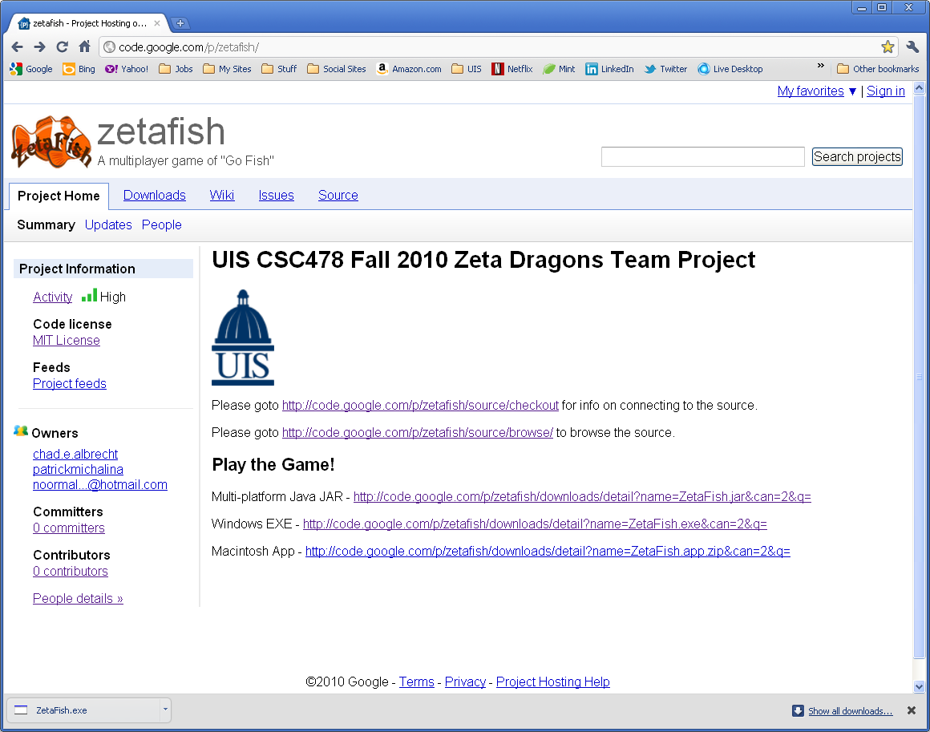

Figure 1 - Downloading the ZetaFish application from the website

## Installation

### Windows

To install ZetaFish on a Windows system simply save the downloaded application in any folder. It is recommended that you store ZetaFish in the Program Files folder and create a link to it on your desktop. Alternatively the EXE file may be placed directly on your desktop and run from there.

### Macintosh

To install ZetaFish on a Macintosh system (OSX 10.5+) simply store the downloaded application in any folder. To start the game double click the icon or select the icon and press Command+O. It is recommended that you store ZetaFish in the Applications folder in your home directory (where most your applications are already stored). Figures 2-4 show someone dragging ZetaFish from the Downloads folder into the Applications folder.

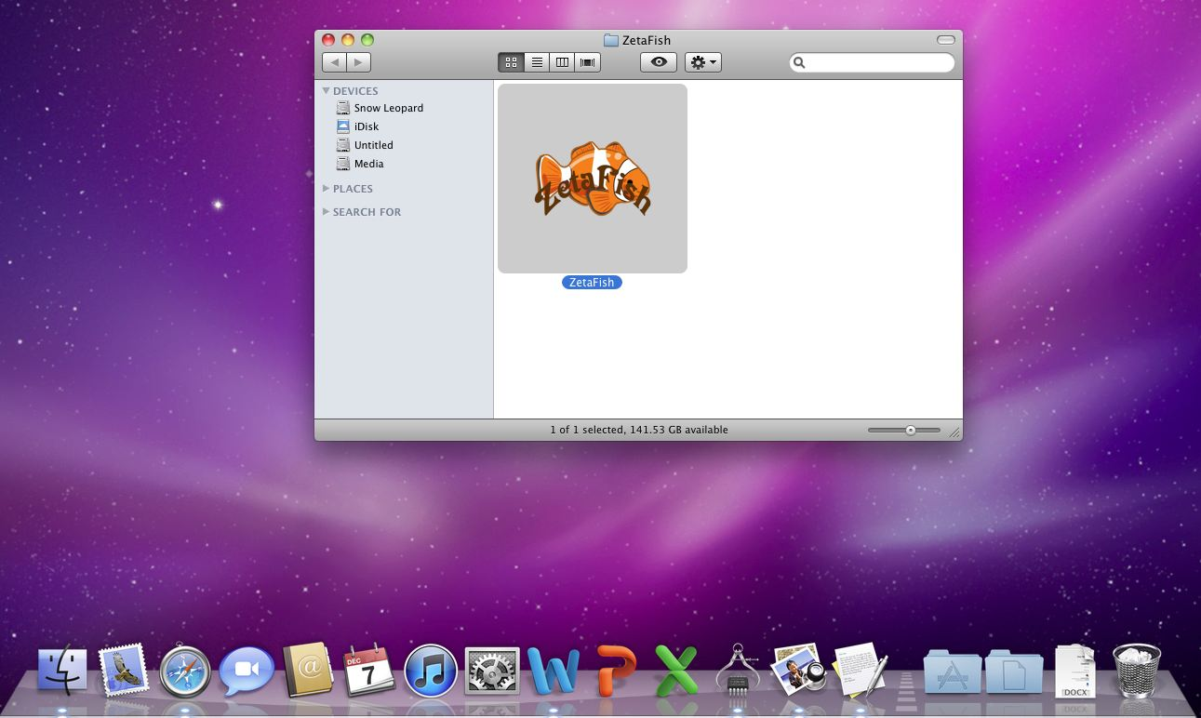

Figure 2 - ZetaFish inside downloads folder.

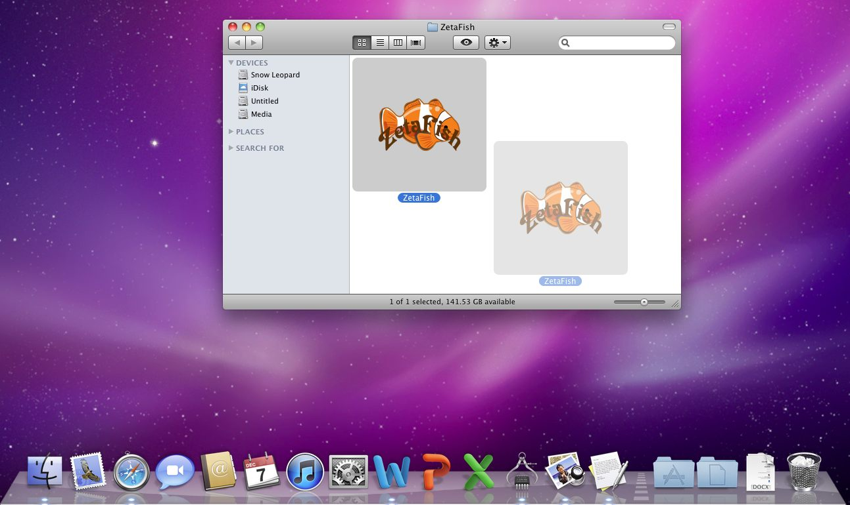

Figure 3 - Halfway to the Applications folder.

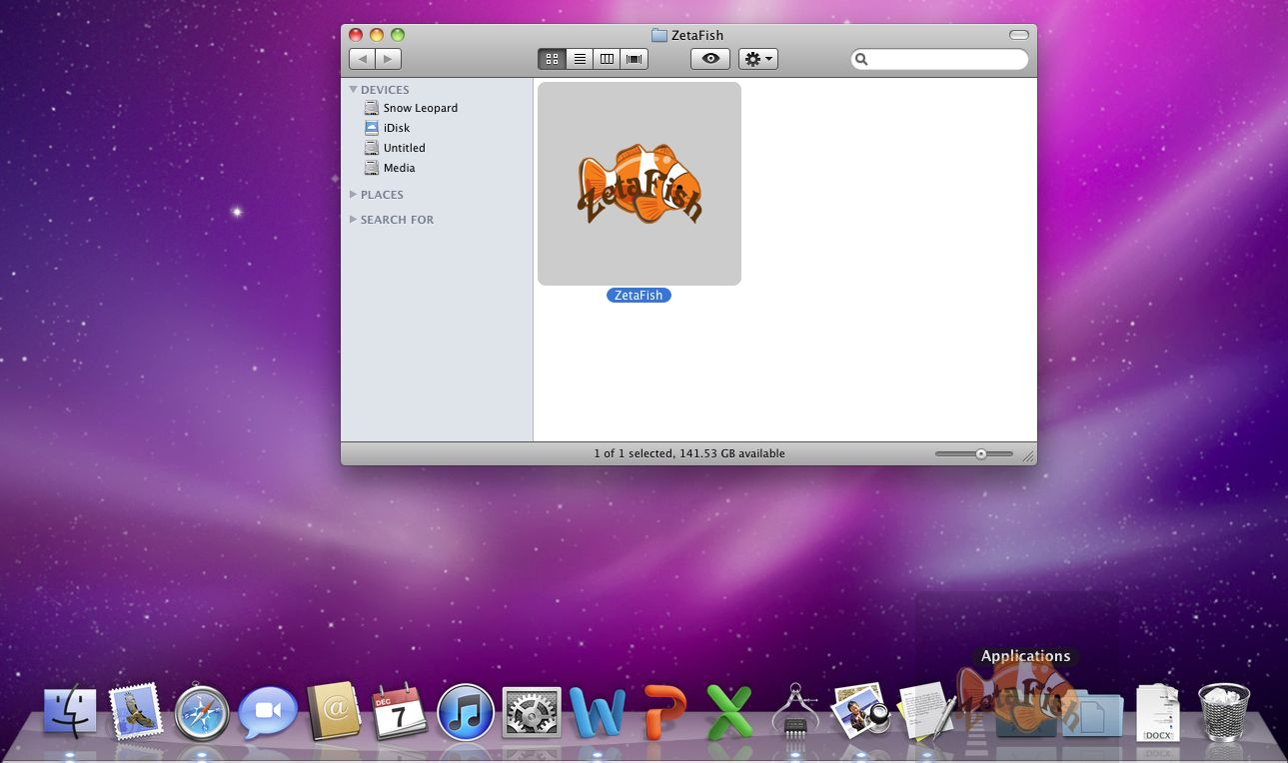

Figure 4 - Application on the target folder.

## Run the executable File

When starting the application you may receive a security warning as shown in Figure 5.

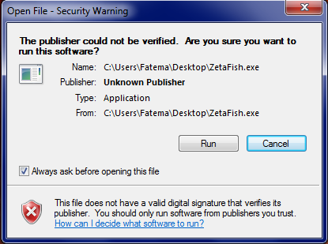

Figure 5 - Security Warning

Since we have not signed the application, this is expected. Click the “Run” button to start the game.

## Start and Play

As soon as the game started, you will see the menu screen as shown in the Figure 6.

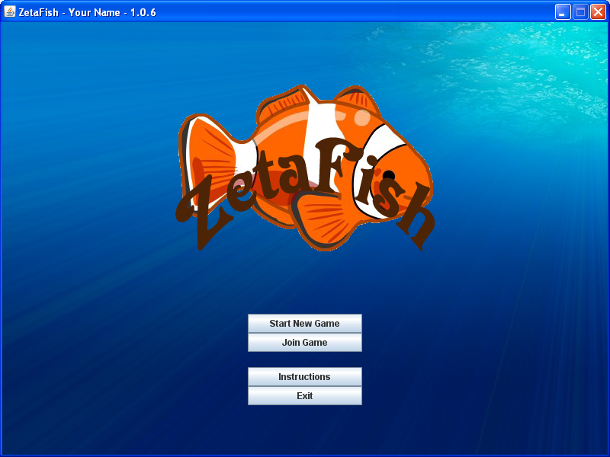

Figure 6 - Menu Screen

Once the Menu Screen is shown (Figure 6), the first player will need to start a new game that other players will connect to. This is done by clicking “Start New Game.” If you would like to join a game created by another player, click “Join Game.” In both cases you will be prompted for your player name as shown in Figure 7.

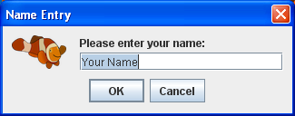

Figure 7 - Player name dialog

If you are joining a game created by another player you will also be prompted for a server name as shown in Figure 8.

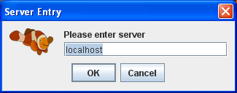

Figure 8 - Server name dialog

The server name is the name of the player’s computer who started the game. This name can typically be found by looking at the system settings on the player’s computer who started the game. (Figure 9) In the case shown in Figure 9 the computer name is “hoth” and would be used as the server name shown in Figure 8.

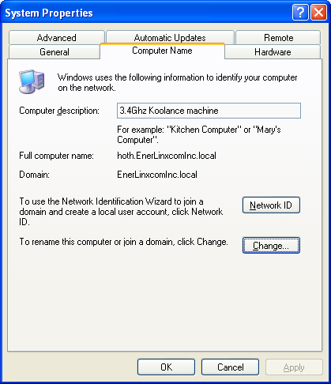

Figure 9 - System Settings

Finally, the bottom two buttons shown in Figure 6 allow you to view the game rules and exit the game respectively.

# How to play the game

Figure 10 shows the intent of each area of the main game play screen.



Figure 10 - Main Screen with Annotation

Details on the annotations shown in Figure 10 are described in Section 5.1.

## Main Screen Details

* Once the game is started, the player whose turn it is to play asks another player for their cards of a particular value. (2’s, Queens, Jacks, etc.)
* Players can request cards from another player by clicking that player’s hand. (Targeted player)
* Target player’s hand is shown in Green Color.
* If the Targeted player has any of the requested cards, they will automatically transfer to the asking player.
* The next turn moves to the next player.
* The current player is denoted with a fish to the right of the player’s hand.
* If the player who was asked has no cards of that value then the asking player draws a card from the ocean automatically.
* When one player has four of the same cards of a given rank, they form a book and may be played at any time.
* Played books are placed face up on the table. Each book worth 1 point.
* If any player run out of cards, the game is over and the player with the most books wins.

# Game Rules

## Player

* ZetaFish is a card game that supports 2 - 6 players over a network.
* Once the game is started, no new player can be added.
* A player can leave the game at any time and his hand would be return to the ocean, while the remaining players would continue their game.
* If the host (player who started the game) exits, the game comes to an end.
* In a two player setting, if any player exit, the game would ends as there would be only one player left.

## Dealer

* The game uses a standard 52 card Deck, with computer as a dealer.
* Each player is initially dealt seven cards.
* The remaining cards are shared between the players, sprawled out in a randomly ordered pile called the "ocean".

## Turn logic

* The player who started the game goes first.
* The remaining players would get their turn in the order they joined the game.
* During a player’s turn they option to pass the turn just by clicking the “End turn” button.
* If a player takes a turn, they ask an opponent for cards by clicking the desired value.
* If the opponent does not have any of the requested card value, the player automatically draws a card from the ocean.
* After receiving cards from an opponent or the ocean, four cards of the same value may be played as a “book” by clicking “Play Books,” otherwise the turn ends.



Figure 11 - Turn Logic

## General Rules

* Players cannot ask for a card they are not holding, and cannot ask for an entire suit.
* The recipient of the request must then hand over all cards of that rank, if they have any.
* When one player has four of the same cards of a given rank, they form a book, and the cards are placed face up on the table. Each book worth 1 point.

## Winner

* The game ends when any player runs out of cards.
* Whoever has the most books wins.

# Future Enhancements

The Zeta Dragon team is looking forward to enhance the game in future and add more functions and choices. In future version of ZetaFish, player may have the option to play with computer, in this case anyone can enjoy the game even when there is no one to play with them.